**PF Lab 5**

You can learn about the **Iomanip library in C++** from the following link.

<https://www.educative.io/answers/iomanip-library-in-cpp>

You are required to write the C++ programs of the following questions. Please make sure to submit a zipped folder(.zip) named ***yourRollNumber (23xxxx).*** Please note that there is **NO** dash(-) and alphabet(i) in the folder name. The folder should contain only .cpp files. **Do not forget to include the iomanip library in your code.**

1. Write a program to draw the following pattern by using the **Setw** function**.**

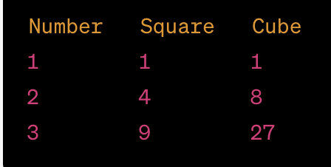

1. Write a program to draw the following pattern by using the **setfill** function**.**

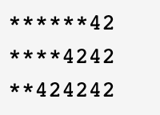

1. Write a program to draw the following pattern by using the **escape sequence (\n, \t, \\, \’ & \” only)** function**.** You are not allowed to insert any space character. Moreover, you have to display this pattern with a single cout statement.

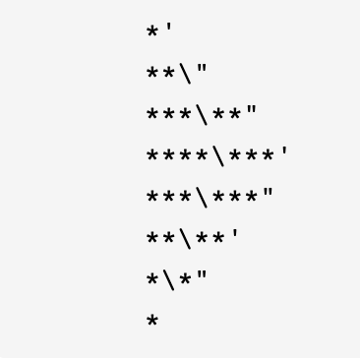

1. Input two numbers and display the result of bitwise operations (AND, OR, XOR). Make sure to use the **iomanip** library for better visualization.
2. Input a number and display the result of bitwise operations (Compliment, leftShift, right shift). Make sure to use the **single cout statement & escape sequence** for better visualization.
3. Write a program to input a number and check if the number is even or odd. You are not allowed to use any arithmetic operator. (Hint: It can be done using a bitwise operator). If you find this problem difficult, no problem. I will explain the logic on board. Don’t google it, and don’t worry about the marks.

To solve this problem follow these steps:

* 1. Convert three to four even decimal numbers into binary on paper.
  2. Convert three to four odd decimal numbers into binary on paper.
  3. Compare the results of a & b, observe to see the pattern.
  4. Then think how the problem can be solved with a bitwise operator

1. Input a small number x and a large number y. Multiply x by 2, 4, 8, & 16 and divide y by 2, 4, 8, 16 using bitwise operators and display the result on console. Make sure to use the iomanip library.

**Make sure to validate the input in the following questions. Moreover, you can use only if statements. Else & else if are not allowed.**

1. Input two float values and display the result of num1/num2 with set precision(3).
2. You are tasked to write a C++ program that calculates the Body Mass Index (BMI) for an individual. BMI is a measure of a person's body weight in relation to their height and is often used to assess whether a person is underweight, normal weight, overweight, or obese.

**Requirements:**

The program should take input from the user for their weight and height.

Calculate the BMI using the formula: BMI = weight (kg) / (height (m) * height (m))

Categorize the BMI value based on the following ranges:

BMI less than 18.5: Underweight

BMI 18.5 to 24.9: Normal weight

BMI 25 to 29.9: Overweight

BMI 30 or greater: Obese

Display the calculated BMI value and the corresponding category (underweight, normal

weight, overweight, or obese). Use iomanip for nice visual representation and setprecision.